STORMW ERCTS

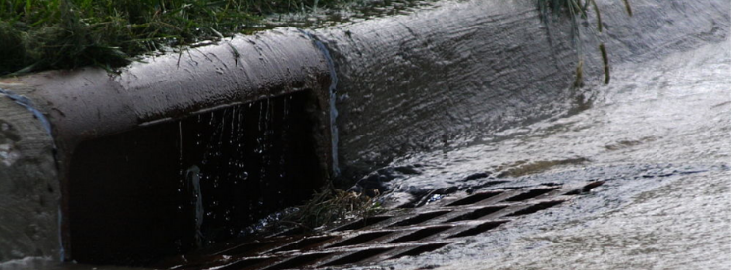Stormwater

There’s been a lot of talk about the Flood Defense Act, and not all of it has been accurate. Here are the facts:

**What is stormwater?**

Stormwater refers to the surface water that is generated during a rainfall or when snow melts. It is also referred to as runoff. In a natural environment, rainwater is absorbed into the soil or makes its way to the nearest gully or stream. In developed areas, rainwater that falls on hard surfaces cannot be absorbed so it must be managed in other ways.

**Why is stormwater a problem?**

Stormwater causes millions of dollars of damage, snarls traffic, threatens drinking water and even endangers lives. When stormwater flows across hard surfaces, it can pick up pollution like oil and grease, toxic chemicals, bacteria and pesticides. In some cities, large rains cause the sewer systems to overflow directly into our sources of drinking water. When this polluted runoff enters our waterways, it makes them unsafe and unhealthy for people and wildlife. Stormwater also causes major flooding issues. Floodwaters damage homes and business, roads and bridges, and create traffic nightmares for commuters.

**How can stormwater pollution affect drinking water?**

Stormwater can carry pollution like toxic chemicals and sewage into drinking our water supplies. This puts an additional burden on our water treatment systems and in some cases can mean that sewage overflows into our waterways without being treated, making drinking water unsafe to drink.

**Why is the problem getting worse?**

New Jersey is one of the most densely populated states in the country. As more open space is developed, it creates more hard surfaces that contribute to flooding and pollution problems when it rains. And, according to meteorologists, severe storms are becoming more frequent due to changing weather patterns. This means we can expect flooding and stormwater pollution to keep getting worse – unless we do something about it.

**What is a stormwater utility/stormwater fee program?**

A stormwater utility is generally regarded as the most effective – and most equitable – model to address the growing threats from stormwater. It is a local, dedicated fund that is treated like water, sewer, electric or other utilities. A stormwater utility assesses a user fee based on how much hard surface, such as concrete, rooftops or pavement, is on a property. The revenue funds stormwater projects and is kept separate from general funds, so it cannot be raided or spent on other needs.

**How much will I have to pay if my community has a flood defense fee?**

Each municipality will be able to set their fee, and the amount will depend on how serious their flooding or pollution problems are, and what they want to do about it. Most communities around the country have their residential fees around a few dollars per month or less.

**How do I know the money will be spent on projects and not used for other things?**

Flood defense fees will go into a dedicated fund that by law can only be spent on stormwater projects and programs. Auditors will monitor these funds to ensure they are not raided or transferred to other needs.

**Is this really a tax on rain?**

No, that would be impossible. Stormwater programs assess a fee on properties with hard surfaces. Unlike pollution that comes from one source, stormwater runoff comes from all of us. We have a shared responsibility to address this threat, and a flood defense fee ensures everyone – including businesses and developers – are paying their fair share.

**What happens now that Flood Defense Act has been signed into law?**

The Flood Defense Act gives New Jersey communities the authority to better clean up polluted runoff and defend themselves against damaging flooding.

The law empowers New Jersey counties and municipalities — on a purely voluntary basis — to create much-needed, community-based stormwater programs that reduce pollution and control local flooding. The legislation makes our neighborhoods cleaner, greener and safer, and can help create good, local jobs.

**Watch this webinar to learn more about how establishing stormwater utilities could help us pave the way forward for a cleaner, greener, and safer New Jersey.**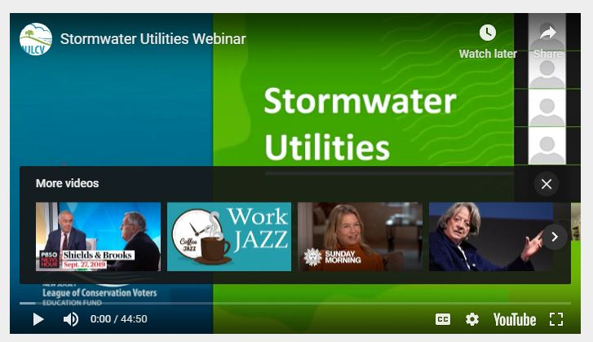

**https://www.youtube.com/watch?v=bMOi7zv_hT0**